**Agenda**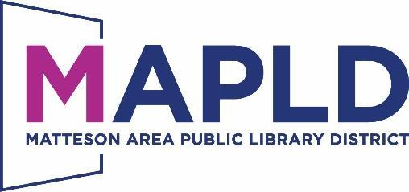

**Board of Trustees Personnel & Policy Meeting**

Tuesday, October 8, 2024 at6:30PM

Room D

801 S. School Avenue

Matteson, Illinois 60443



**THIS MEETING IS OPEN TO THE PUBLIC**

If you anticipate needing any type of accommodations or have questions about the physical access provided, please call (708) 748-4431 in advance of your participation or visit.

***Items that are not listed on the agenda are for discussion only.***

**1. Call to Order**

***Our Mission****: The library is an important community partner that disseminates knowledge for the benefit of society and provides* ***quality programs*** *and* ***services*** *for* ***all ages*** *thus bringing people together, fostering creativity, and encouraging lifelong learning.*

***Our Vision:*** *We strive to be a library that is integral to the lives of all residents, by providing an inviting center which offers a diverse spectrum of innovative services, materials, and programming to* ***enrich, transform****, and* ***empower*** *our community.*

**2. Roll Call**

**3. Opportunity for Public Comment**

**4. Closed Session**

*Motion to go into closed session for the purpose of under Illinois State Statute*

*(5ILCS120) Open Meetings Acts. Closed Session for reasons of appointment,*

*Employment, and compensation of specific employees of a public body.*

**5. Other**

**6. Final Thoughts**

**7. Adjournment**