**Agenda**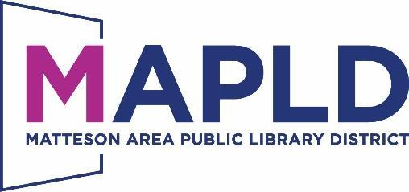

**Budget & Appropriation Ordinance Hearing**

Tuesday, September 17, 2024 at6:45PM

Room A

801 S. School Avenue

Matteson, Illinois 60443

**THIS MEETING IS OPEN TO THE PUBLIC**

If you anticipate needing any type of accommodations or have questions about the physical access provided, please call (708) 748-4431 in advance of your participation or visit.

**Legal Notice**: Public Hearing will be held in connection with the Tentative Budget and Appropriation Ordinance No. 2024-3 for Fiscal Year Beginning July 1, 2025 and Ending June 30, 2026 at 6:45p.pm.

***Items that are not listed on the agenda are for discussion only.***

**1. Call to Order**

**2. Ordinance No. 2024-3**

In Illinois, a budget and appropriation ordinance is a yearly ordinance that all municipalities must adopt within the first quarter of the fiscalyear. The ordinance must include:

* An estimate of the cash on hand at the start of the fiscal year *($5,006,619.65)*
* An estimate of the cash expected to be received during the fiscal year *($3,603,500)*
* An estimate of the expenditures for the fiscal year *($3,322,500.00)*
* A statement of the estimated cash on hand at the end of the fiscal year *($2,258,876.00)*

The ordinance also specifies the amount appropriated for each purpose and the purpose for which the appropriations are made.

**3.** **Public Comments on the Budget & Appropriation Ordinance**

**4. Trustee/Staff Comments on the Budget & Appropriation Ordinance**

**5. Adjournment**